STEP:1 DOWNLOAD HIBERNATE JAR FILES

LINK: https://jar-download.com/artifacts/org.hibernate/hibernate-core

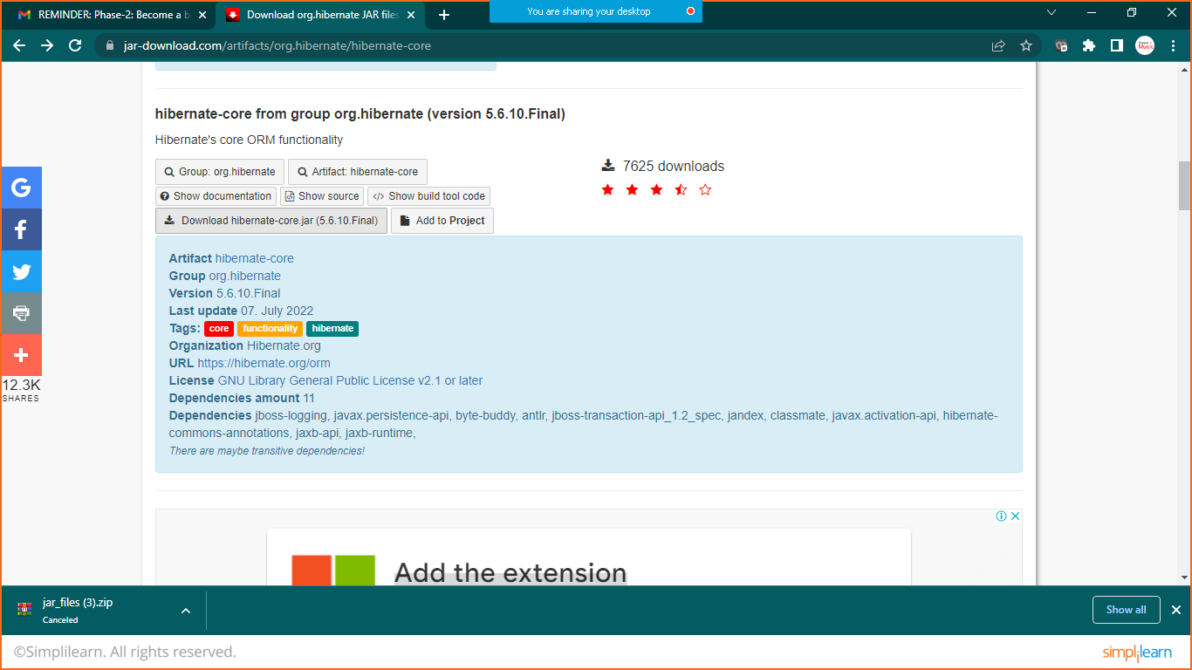

STEP:2 EXTRACT JAR FILES TO FOLDER

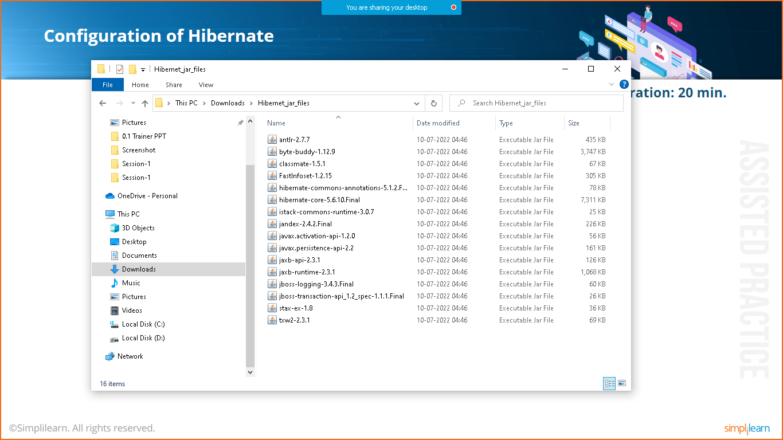

STEP:3 DOWNLOAD MY SQL CONNECTOR

LINK: <https://dev.mysql.com/downloads/connector/j/?os=26>

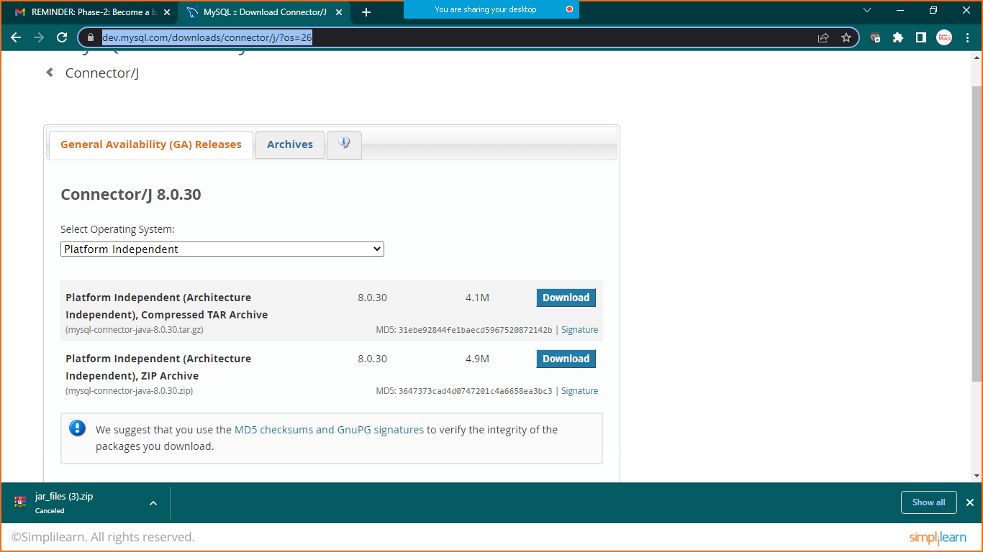

STEP:4 EXTRACT THE MYSQL CONNECTOR

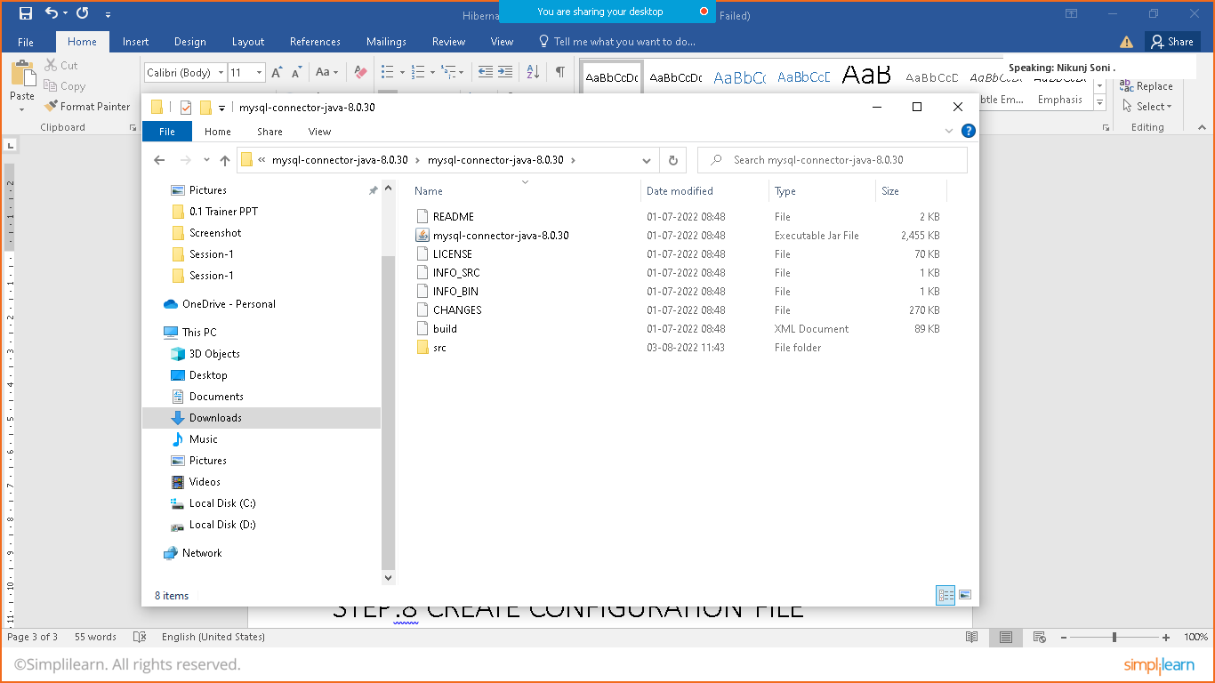

STEP:5 CREATE SIMPLE JAVA PROJECT

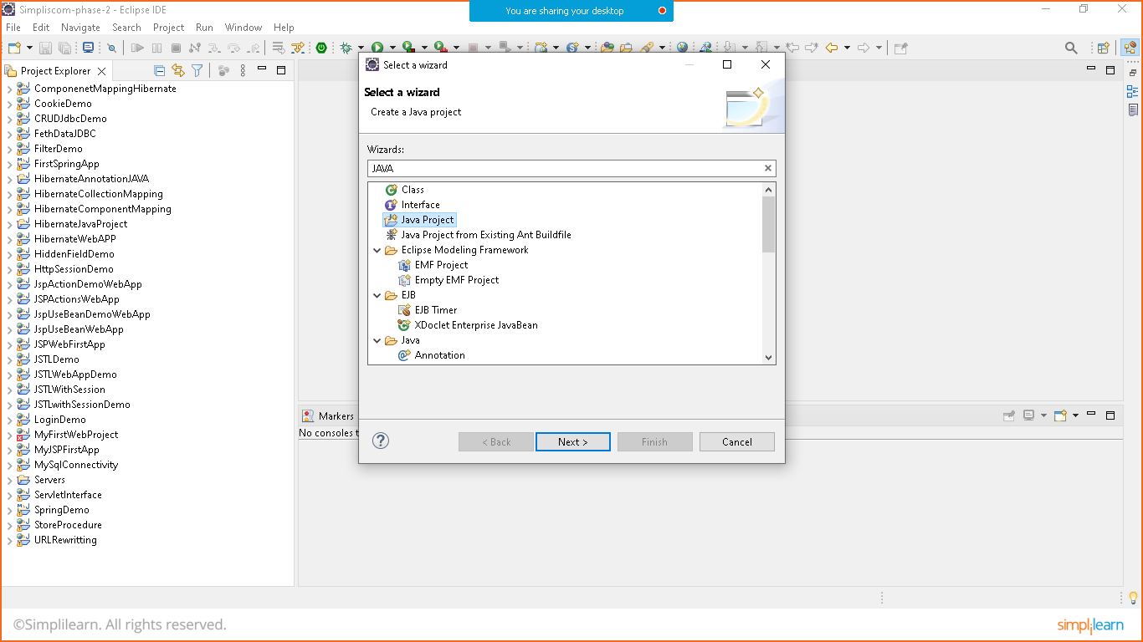

Give the name: HibernateProject_First_Aug

STEP:6 ADD HIBERNATE AND MYSQL CONNECTOR LIBRARY FILE

Right click on project> buildpath>configure build path>select library tab>click on classpath>add external jar button> select jar files of hibernate and my sql connector that we had extracted >click on apply and apply and close

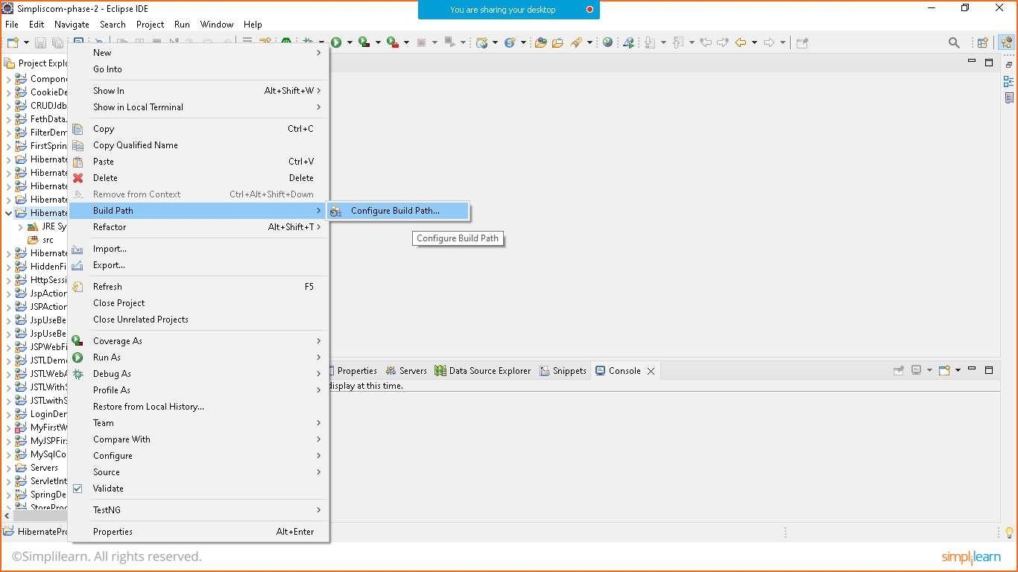

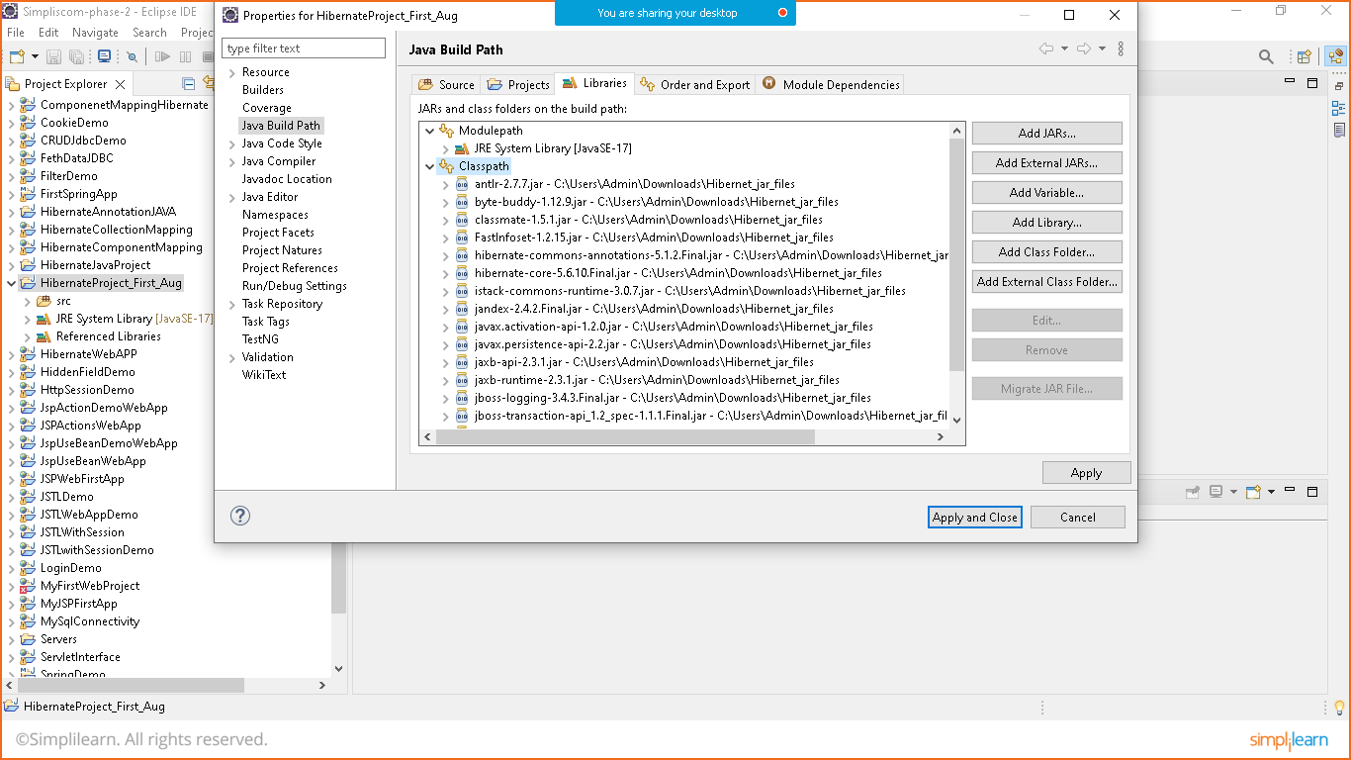

STEP:7 CREATE POJO (BEAN CLASS)

Student.class

**package** com.simplilearn.demo;

**public** **class** Student {

**private** **int** id;

**private** String name;

**private** String email;

**private** String password;

**public** **int** getId() {

**return** id;

}

**public** **void** setId(**int** id) {

**this**.id = id;

}

**public** String getName() {

**return** name;

}

**public** **void** setName(String name) {

**this**.name = name;

}

**public** String getEmail() {

**return** email;

}

**public** **void** setEmail(String email) {

**this**.email = email;

}

**public** String getPassword() {

**return** password;

}

**public** **void** setPassword(String password) {

**this**.password = password;

}

}

STEP:8 CREATE CONFIGURATION FILE

Goto>src>right click>new >other>xml >select xml file>give name (hibernate.cfg.xml)

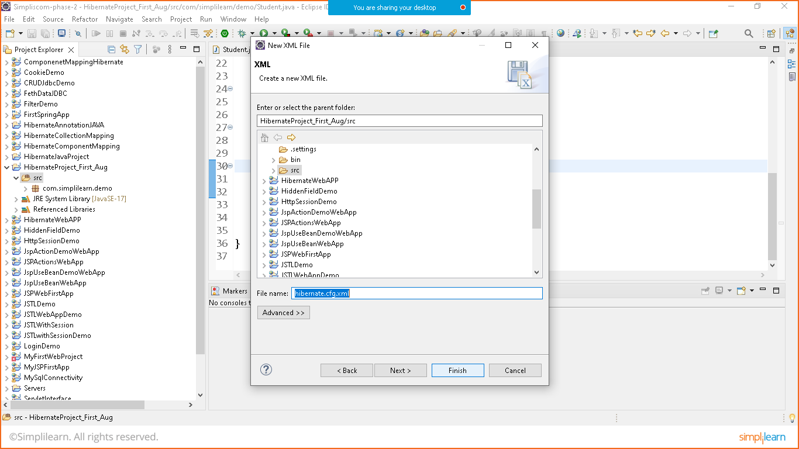

Click on reference library>hibernate 5.6.10>expand orm.hibernate>scroll down to bottom as shown below

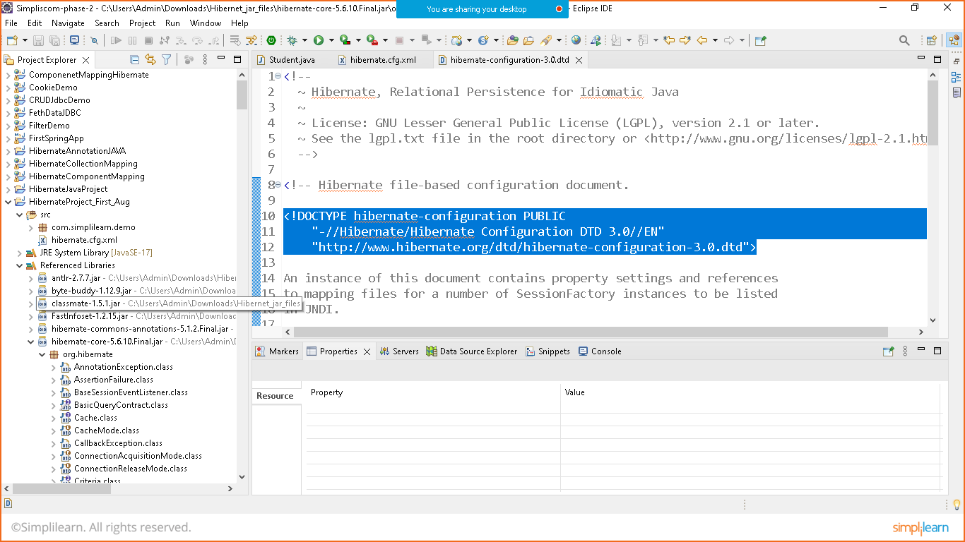

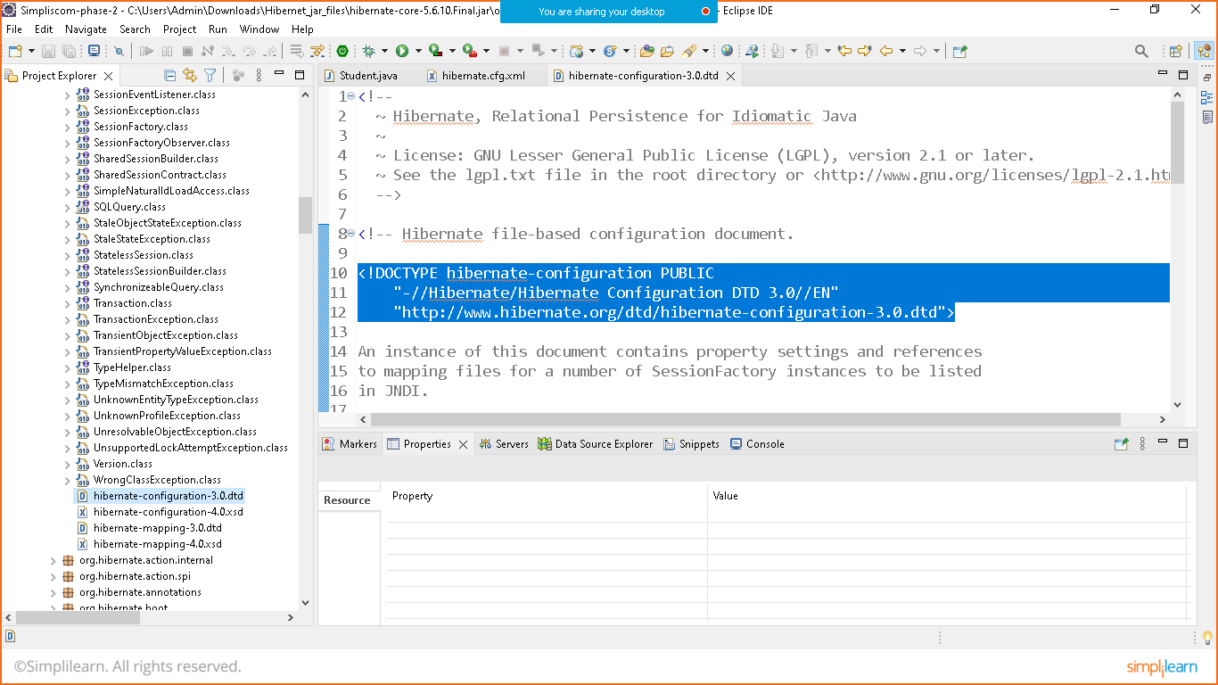

<!DOCTYPE hibernate-configuration PUBLIC

"-//Hibernate/Hibernate Configuration DTD 3.0//EN"

"http://www.hibernate.org/dtd/hibernate-configuration-3.0.dtd">

Hibernate.cfg.xml

<?xml version=*"1.0"* encoding=*"UTF-8"*?>

<!DOCTYPE hibernate-configuration PUBLIC

"-//Hibernate/Hibernate Configuration DTD 3.0//EN"

"http://www.hibernate.org/dtd/hibernate-configuration-3.0.dtd">

<hibernate-configuration>

<session-factory>

<property name=*"connection.driver.class"*>com.mysql.cj.jdbc.Driver</property>

<property name=*"connection.url"*>jdbc:mysql://localhost:3306/hibernate_aug</property>

<property name=*"connection.username"*>root</property>

<property name=*"connection.password"*>Nikunj@123</property>

<property name=*"hbm2ddl.auto"*>update</property>

<mapping resource=*"student.hbm.xml"*/>

</session-factory>

</hibernate-configuration>

STEP:9 CREATE MAPPING FILE

Goto>src>right click>new >other>xml >select xml file>give name (student.hbm.xml)

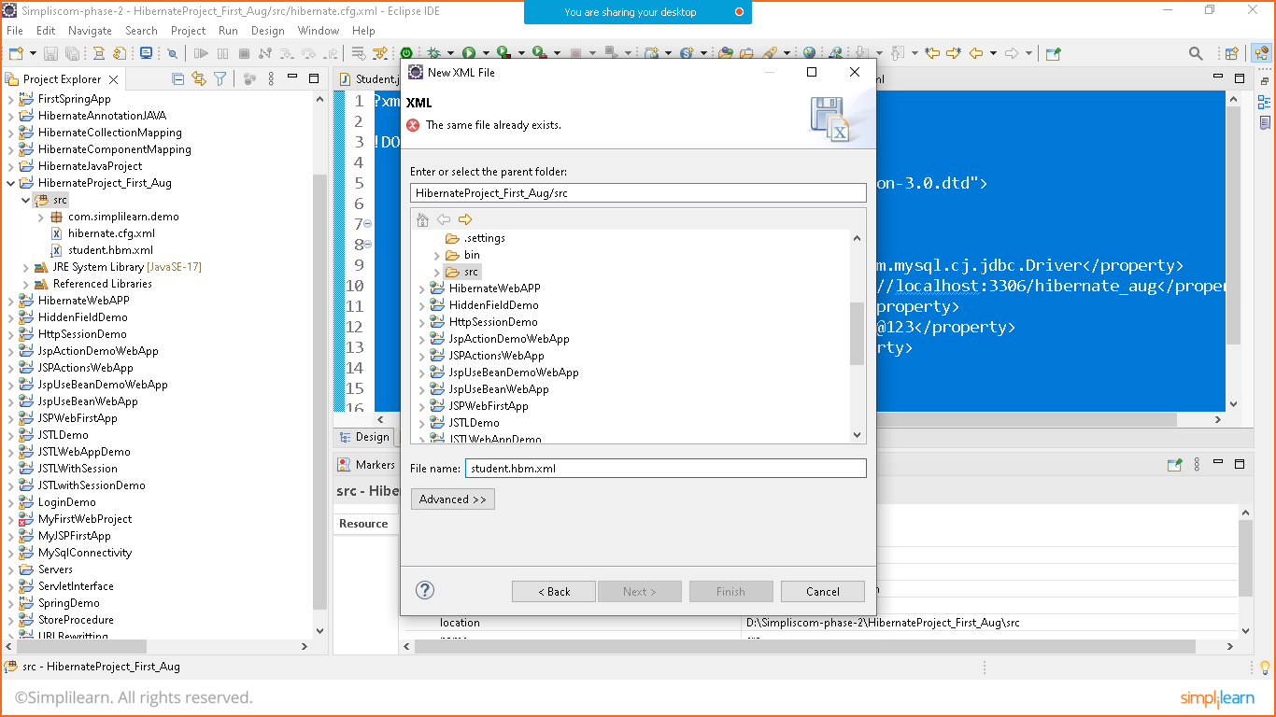

Click on reference library>hibernate 5.6.10>expand orm.hibernate>scroll down to bottom as shown below

Open hibernate-mapping.3.0 dtd file and copy the code as shown here

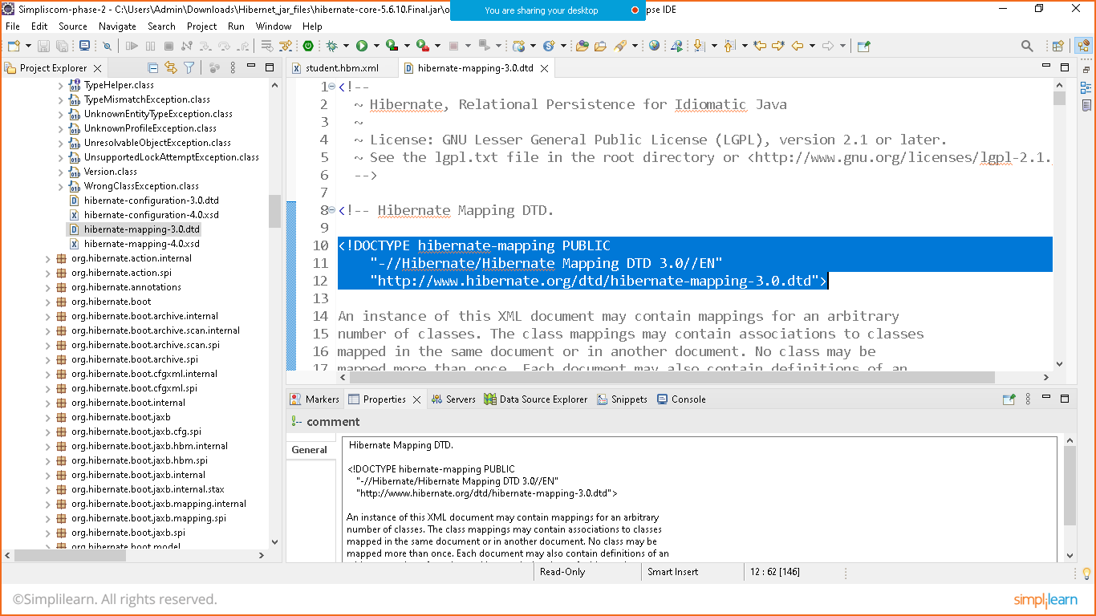

<!DOCTYPE hibernate-mapping PUBLIC

"-//Hibernate/Hibernate Mapping DTD 3.0//EN"

"http://www.hibernate.org/dtd/hibernate-mapping-3.0.dtd">

Student.hbm.xml

<?xml version=*"1.0"* encoding=*"UTF-8"*?>

<!DOCTYPE hibernate-mapping PUBLIC

"-//Hibernate/Hibernate Mapping DTD 3.0//EN"

"http://www.hibernate.org/dtd/hibernate-mapping-3.0.dtd">

<hibernate-mapping>

<class name=*"com.simplilearn.demo.Student"*>

<id name=*"id"*>

<generator class=*"increment"*></generator>

</id>

<property name=*"name"* type=*"string"*></property>

<property name=*"email"* type=*"string"*></property>

<property name=*"password"* type=*"string"*></property>

</class>

</hibernate-mapping>

STEP:10 RUN THE PROGRAMM

Prepare one main class and main method to run the program

Main.class

**package** com.simplilearn.demo;

**import** org.hibernate.Session;

**import** org.hibernate.SessionFactory;

**import** org.hibernate.Transaction;

**import** org.hibernate.boot.Metadata;

**import** org.hibernate.boot.MetadataSources;

**import** org.hibernate.boot.registry.StandardServiceRegistry;

**import** org.hibernate.boot.registry.StandardServiceRegistryBuilder;

**public** **class** Main {

**public** **static** **void** main(String[] args) {

StandardServiceRegistry registry= **new** StandardServiceRegistryBuilder().configure("hibernate.cfg.xml").build();

Metadata metadata= **new** MetadataSources(registry).getMetadataBuilder().build();

//connection pool

SessionFactory factory= metadata.getSessionFactoryBuilder().build();

//let's take databse connection to do transaction

//prepare one database in mysql with name 'hibernate_aug' before executing below code

Session session= factory.openSession();

Student s1= **new** Student();

s1.setName("Nikunj");

s1.setEmail("nikunj@gmail.com");

s1.setPassword("Nikunj@123");

Transaction tx= session.beginTransaction();

session.save(s1);

tx.commit(); //to save the data //automatically creates the table in db and add the data inserted in the same

session.close();

factory.close();

System.***out***.println("Data Inserted Successfully");

}

}

Also create database

Hibernate_aug

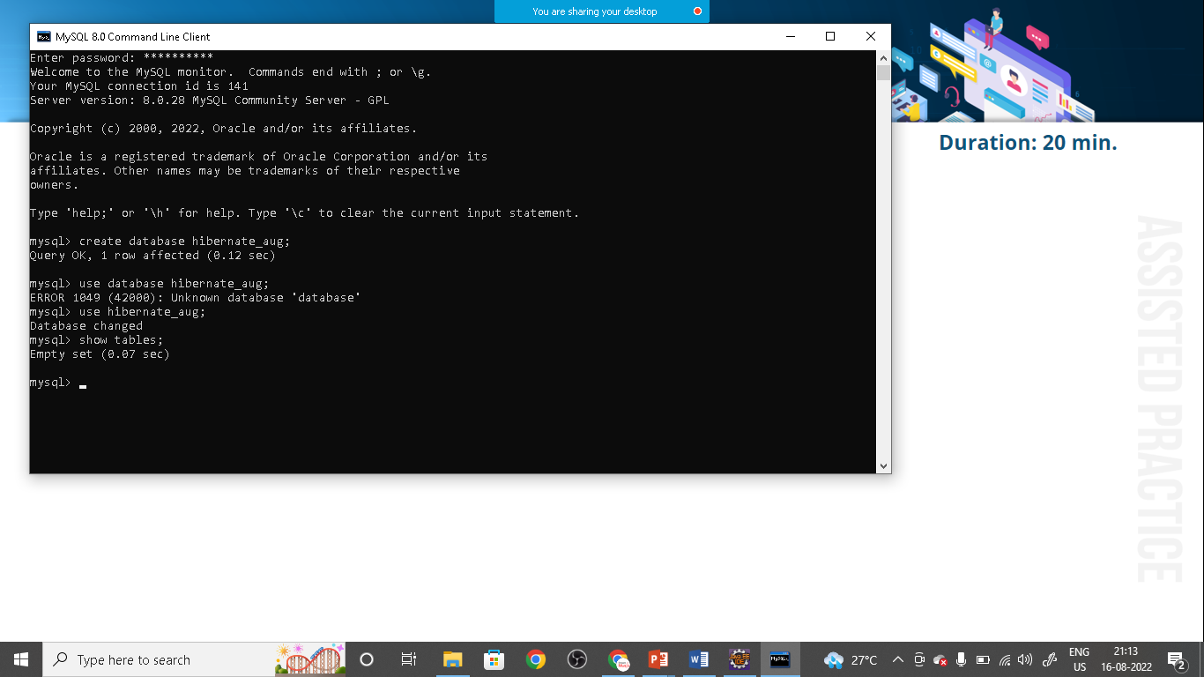

Run the program

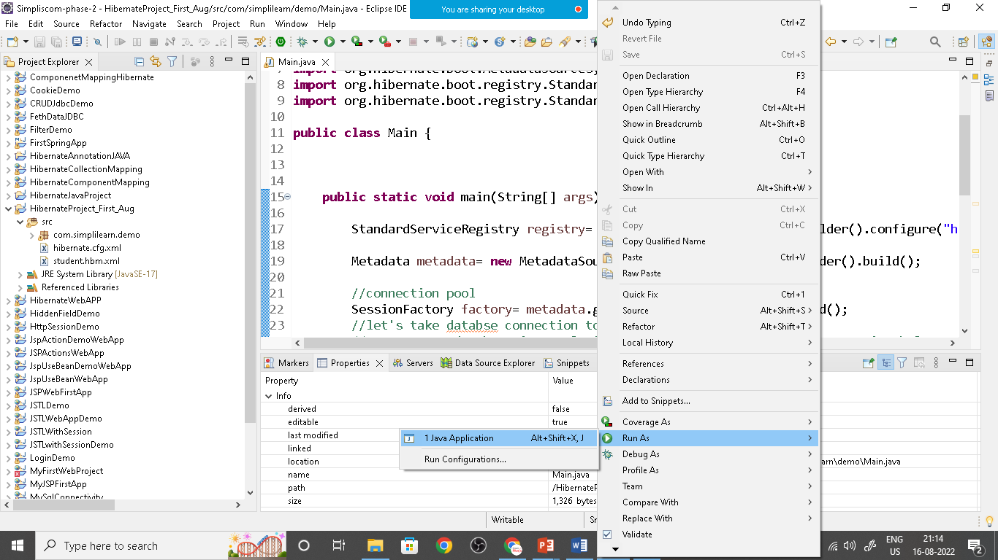

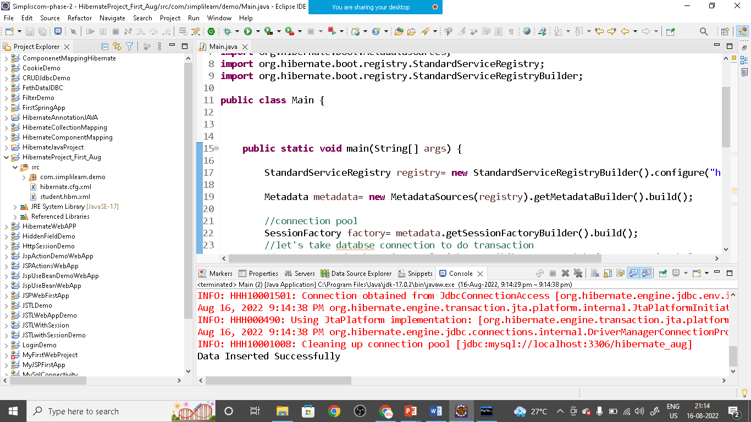

Check the databse :

